

BLUE HAWK SOCCER BOOSTER SCHOLARSHIP APPLICATION
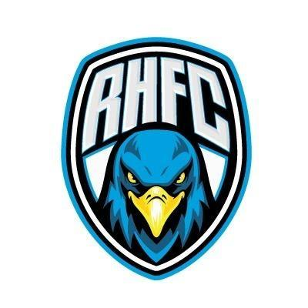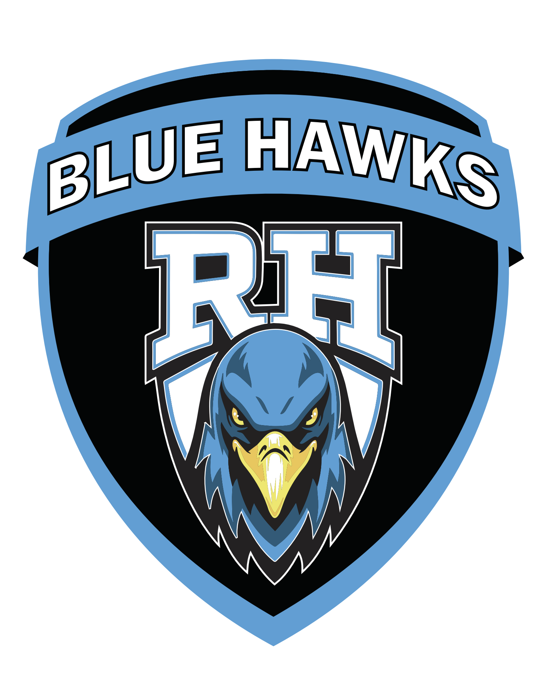



BLUE HAWK SOCCER BOOSTER
SCHOLARSHIP APPLICATION

PURPOSE
To recognize and reward a deserving senior varsity soccer player and to aid him/her in his/her future academic endeavors.

CRITERIA FOR AWARD & SCHOLARSHIP

SOCCER
- Length of participation in school sponsored program
- Recognition and awards given as a result of RHHS soccer participation

ACADEMICS
- List of types of courses taken (Honors, Advanced, College)
- Verification of GPA signed off by school Counselor

EXTRACURRICULAR ACTIVITIES
- School Activities – clubs, organizations, activities that are school sponsored
- Non-school sponsored activities – Community involvement, church activities, soccer participation outside of RHHS, etc.

COACH RECOMMENDATION
• Will be based on the attitude of the individual, cooperation with coach and staff, level of attendance to practice and team events, team interaction, leadership qualities.

SUPPLEMENT RECOMMENDATIONS
- Letter of recommendation from a non-coaching individual employed by school, to be addressed with the student school ID#
- Recommendations will be sent to the respective head soccer coach in a sealed self-addressed (envelope provided) with the student ID# on the outside

SCHOLARSHIP
A scholarship or scholarships of $500 each will be awarded to selected senior varsity soccer players, and applied to tuition and fees at an accredited institution, upon verification of recipient’s acceptance by the institution and after enrollment. This will be a non-renewable scholarship. Scholarship awards are based on the applicant being a qualified senior in the program.
The scholarship program is subject to modification on an annual basis. The number of scholarship awards and the amount of each will be determined by the Blue Hawk Soccer Booster Club each year and is based on funds available.

SELECTION PROCESS
Each soccer season the coaching staff will distribute the Blue Hawk Soccer Booster Scholarship program application to all eligible senior players. NOTE: Applications for 2022-2023 are due to your coaches by March 17, 2023. In an effort for the applicants to remain anonymous during the selection process, please do not use the applicants name on any of the application paperwork. Please use only the student’s ID#
Applications will be reviewed by an independent panel to be selected by the Blue Hawk Soccer Booster Club Board of Directors. This panel will have no affiliation with the Blue Hawk Soccer Booster Club. The selection process will be by a sliding point system based on a 20 point maximum inclusive of the 5 listed award criteria.
If the student does not maintain outstanding citizenship and attitude during the entire senior school year including the time after the awarding of the Blue Hawk Soccer Booster Scholarship has been awarded, the Blue Hawk Soccer Booster Board of Directors reserves the right to reconvene and vote to withdraw the award. Notification of any such action must be given to the recipient prior to graduation.

PRESENTATION OF SCHOLARSHIP
Scholarship selection will be announced at the soccer awards banquet on a date determined by the Blue Hawks Soccer Booster Club on an annual basis.

ENGAGEMENT OF SCHOLARSHIP
The engagement of the scholarship will be paid upon receipt of evidence of acceptance and enrollment in an accredited institution. This evidence of acceptance must be received by the Blue Hawk Soccer Booster Club within one year from award date or the scholarship will be forfeited. Forfeited awards will be returned to Blue Hawk Soccer Booster Clubs general fund.



BLUE HAWK SOCCER BOOSTER

SCHOLARSHIP APPLICATION

Applicant’s Student ID#: ________________________

High School Soccer Resume
On this page please provide your soccer resume as it pertains to your playing experiences during your High School years. Please include all time on the Varsity and Junior Varsity level during your RHHS soccer years. Also list any recognitions or awards given as a result of your participation in Blue Hawk Soccer. (Please add additional pages if needed.)

Level | 9th Grade | 10th Grade | 11th Grade | 12th Grade
Junior Varsity
Varsity
Club Soccer

High School Soccer Awards or recognitions:
____________________________________________________________________________________________________________________________________________________________________________________________________________________________________________________________________________________________________________________________________________________________________________________________________________________________________________________________________________________________________________________________________________________________________________________________________________________________________________________________________________________________________________________________________________________________________________________________________________________________________________________________________________________________


BLUE HAWK SOCCER BOOSTER

SCHOLARSHIP APPLICATION

Applicant’s Student ID#: ________________________

Academics
On this page please provide your cumulative Grade Point Average provided to you and verified by the Prosper Independent School District. Please have a Counselor of Rock Hill High School sign this form to provide the verification of your GPA. Also, on this form please list any and all Honors Courses, Advanced Classes, or College Courses that you have taken. (Please add additional pages if needed.)
Your Rock Hill Grade High School Point Average ___________

Your Rock Hill High School Counselor’s Printed Name ______________________________

Your Rock Hill High School Counselor’s Signature ______________________________

List Courses (Honors, Advanced or College level): __________________________________________________________________________________________________________________________________________________________________________________________________________________________________________________________________________________________________________________________________________________________________________________________________________________________________________________________________________________________________________________________________________________________________________________________________________________________________________________________________________________________________________________________________________________________________________________________________________________________________________________________________________________________________________________________________________________________________________________

BLUE HAWK SOCCER BOOSTER SCHOLARSHIP APPLICATION

Applicant’s Student ID#: ________________________

Extracurricular Activities
On this page, please list any extracurricular activities of which you have been a part during your time in High School. These should include school-sponsored clubs, organizations, and activities. Also, include non-school related activities, such as community involvement projects, church related activities, non-school sponsored soccer participation, or volunteer work. (Add additional pages if needed.)
_________________________________________________________________________________________________________________________________________________________________________________________________________________________________________________________________________________________________________________________________________________________________________________________________________________________________________________________________________________________________________________________________________________________________________________________________________________________________________________________________________________________________________________________________________________________________________________________________________________________________________________________________________________________________________________________________________________________________________________________________________________________________________________________________________________________________________________________________________________________________________________________________________________________________________________________________________________________________________________________________________________________

BLUE HAWK SOCCER BOOSTER SCHOLARSHIP APPLICATION

Applicant’s Student ID#: ________________________

Letter of Recommendation from RHHS Employee

On this page please attach a letter of recommendation from a non-coaching individual employed by the school, to be addressed with the student school ID#. (Add additional pages if needed. )
Please have the individual employed by Rock Hill High School return their letter directly to your respective head coach at Rock Hill High School no later than March 17, 2023. Any application received later than this date will not be accepted.

BLUE HAWK SOCCER BOOSTER SCHOLARSHIP APPLICATION

Applicant’s Student ID#: ________________________

Coaches’ Recommendations
Please read the description of the desired characteristic and rate the athlete on the scale of 1-5. If you would like to comment further, please use the space below the characteristic listed.
